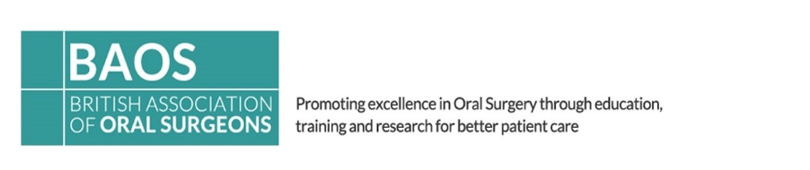

BAOS Annual Competition

2021 Poster Abstract Submission

Poster Categories: 1. Audit / Service Improvement, 2. Case reports, 3. Research

Prizes: One Winner for each Category above (£150)

Abstracts of all Posters selected for the online Poster Exhibition on the BAOS website will have the chance to be published in the BAOS Oral Surgery Journal. * Oral Surgery Journal Publications are at the discretion of the Editor.

The abstracts must therefore be submitted in a standard format for publication.

This work should not have been previously published or presented elsewhere.
This work should only be entered once. Either for the Open Paper competition or for the Poster Competition.

Only abstracts from entrants who apply to attend the online event will be considered. Each abstract will then be reviewed and will be selected for the online Poster Exhibition and Competition on the basis of the quality of the work as judged from the abstract.

Submission of Abstract

The abstract must be typed and fit within the box on the online abstract application form using a maximum of 300 words.

Closing date:
Abstracts must be received no later than Tuesday 16 February 2021.

Electronic submissions only. Receipt of abstracts will be acknowledged by automatic email. Please ensure your email address is included on the abstract submission form.

BAOS Annual Competition

2021 Poster Abstract Submission

Guidance Information

** Please read this information before submitting your abstract **

Content of the Abstract

The abstract must contain
- The title of the presentation; maximum 10 words or less
- The name of the presenter and co-author(s)
- The institution of the authors.

The abstract must also contain a brief statement of:
- The objectives of the investigation,
- Experimental methods used,
- Essential results, including data and, where appropriate, statistics,
- Conclusion
To achieve a more consistent style, the words: "Objectives:", "Methods:", "Results:", and "Conclusion:" each immediately followed by a colon as shown, must appear in the body of your abstract.

DOs and DON'Ts
- DON'T include illustrations or photos, although tables, charts and columns may be used.
- DON'T submit abstracts reporting studies with unidentified drugs or materials. They will not be accepted.
- DO mention the name of a commercial product if used in the research but only once.
- DO disclose external funding (required) by listing the name of supporting agency and grant number in the body of the text.
- DO make sure the abstract is typed within the abstract box otherwise it will not be accepted
- DO limit the number of words in the abstract to 300 or less. Larger abstracts will not be accepted. Titles are limited to 10 words or less.

BAOS Annual Competition

2021 Poster Abstract Submission

Sample Abstract

Presenter’s Name(s): Danyal Awal and Ambareen Naqvi
Authors: Danyal Awal, Ambareen Naqvi and Sonita Koshal
Email address: joebloggs@nhs.net
Hospital: Department of Oral Surgery, Eastman Dental Hospital, UK
Title: The Internet resources available regarding the Coronectomy procedure

Background: The Coronectomy procedure is an increasingly common technique for treating wisdom teeth that have an intimate relationship with the inferior dental nerve. The Internet is a widely used source for seeking out healthcare information, yet it remains largely unregulated and the quality and accessibility of information varies widely.

Objectives: The objective was to systematically review the quality of information available on the Internet for patients regarding the Coronectomy procedure.

Method: Using the search terms ‘Coronectomy’ and ‘Intentional Partial Odontectomy’, 2 clinicians independently assessed the top 100 websites using the UK version of the search engine ‘Google’. The DISCERN instrument for assessing the quality of healthcare information was used to objectively score the sites and an average calculated for each.

Results: 97% (97/100) of the websites were readily accessible and 7% (7/100) excluded in accordance with our exclusion criteria bringing the total number of websites to 93. 87% (81/93) of the sites presented information in English only, 61% (57/93) had a health related seal of approval and 5% (5/93) had some form of interactive media. 56% (52/93) were associated with journals or books and aimed at healthcare professionals while 44% (41/93) of the sites were targeted towards consumers. With a maximum score of 80, the average DISCERN score was 48.8 with no discernable pattern evident between a websites score and its rank of search.

Conclusion: The quality of information on the Coronectomy procedure available on the Internet is generally moderate, with a majority being aimed at healthcare professionals. Due to this, patients may find it difficult to find accessible and reliable information and thus may stray towards biased, less regulated sources. Patients should be guided to use reliable sources of information and can be achieved by providing leaflets on consultation indicating the best websites to use.

Updated 5 Jan 2021

